**Topics: Normal distribution, Functions of Random Variables**

1. The time required for servicing transmissions is normally distributed with *μ* = 45 minutes and *σ* = 8 minutes. The service manager plans to have work begin on the transmission of a customer’s car 10 minutes after the car is dropped off and the customer is told that the car will be ready within 1 hour from drop-off. What is the probability that the service manager cannot meet his commitment?
2. 0.3875
3. 0.2676
4. 0.5
5. 0.6987

Ans. The manager plans to start the work 10mins after dropping off (I.e x=60mins-10mins=50mins) x=50mins. According to this the manager has to complete the servicing in 50mins.

Code:-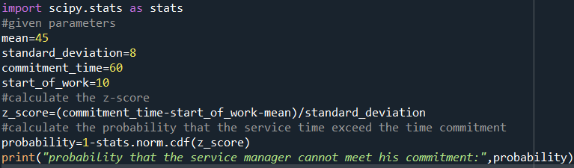

Output:-

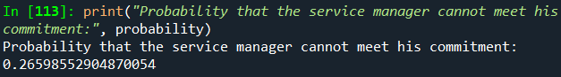

As the output value is (0.2659) is approximately equal to 0.2676. **The correct option is B.**

1. The current age (in years) of 400 clerical employees at an insurance claims processing center is normally distributed with mean *μ* = 38 and Standard deviation *σ* =6. For each statement below, please specify True/False. If false, briefly explain why.
2. More employees at the processing center are older than 44 than between 38 and 44.
3. A training program for employees under the age of 30 at the center would be expected to attract about 36 employees.

ANS:- Statement **A** is **FALSE.**

From the above statement, mean = 38, standard deviation = 6 and the range lies in between 38 and 44 which includes one standard deviation above the mean. Approximately 68% of the data falls within one standard deviation of the mean in a perfectly symmetric normal distribution which means that the number of employees between 38 and 44 should be greater than the number of employees older than 44, not the other way around.

Statement **B** is **TRUE.**

1. If *X1* ~ *N*(μ, σ2) and *X*2 ~ *N*(μ, σ2) are *iid* normal random variables, then what is the difference between 2 *X*1 and *X*1 + *X*2? Discuss both their distributions and parameters.

ANS:-

For the random variable 2X1:

Mean (average):- 2 times the mean of X1, which is 2μ.

Variance:- 4 times the variance of X1, which is 4σ^2.

For the random variable X1 + X2:

Mean(average): The sum of the means of X1 and X2, which is 2μ.

Variance: The sum of the variances of X1 and X2, which is 2σ^2.

* So, both 2X1 and X1 + X2 have the same mean which is 2μ.
* As the variance of 2X1 is 4 times the variance of X1, 2X1 variance is larger than the variance of X1+X2 which is 2σ^2.

1. Let X ~ N(100, 202). Find two values, *a* and *b*, symmetric about the mean, such that the probability of the random variable taking a value between them is 0.99.
2. 90.5, 105.9
3. 80.2, 119.8
4. 22, 78
5. 48.5, 151.5
6. 90.1, 109.9

ANS:-

Code

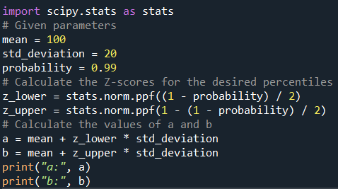

Output:-

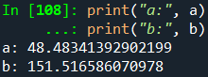

As the output value is (48.48,151.51) is approximately equal to 48.5,151.5.**The correct option is D.**

1. Consider a company that has two different divisions. The annual profits from the two divisions are independent and have distributions Profit1 ~ N(5, 32) and Profit2 ~ N(7, 42) respectively. Both the profits are in $ Million. Answer the following questions about the total profit of the company in Rupees. Assume that $1 = Rs. 45
2. Specify a Rupee range (centered on the mean) such that it contains 95% probability for the annual profit of the company.
3. Specify the 5th percentile of profit (in Rupees) for the company
4. Which of the two divisions has a larger probability of making a loss in a given year?

ANS:-

1. To specify a rupee range (centered on the mean) containing 95% probability for the annual profit of the company, we need to find the mean and standard deviation of the total profit:

Total Profit ~ N(mean total, standard deviation total).

code:-

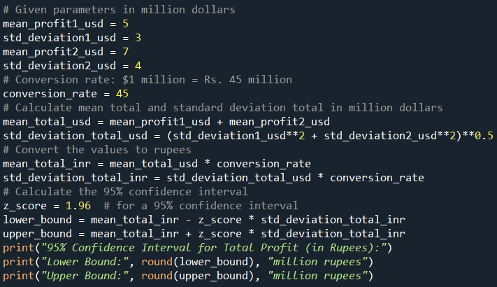

Output:-

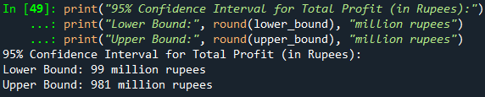

1. The 5th percentile corresponds to -1.645 standard deviations below the mean. So, the 5th percentile in rupees is:

Code:-

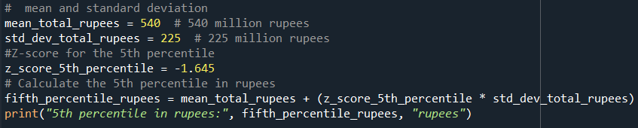

Output:-



1. To determine which of the two divisions has a larger probability of making a loss, we can calculate the probability of each division making a loss.

Code:-

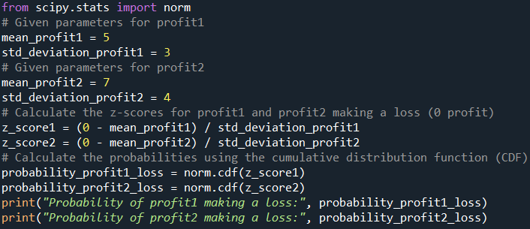

Output:-

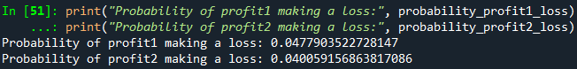

**Conclusion:- profit2 is making a larger loss while compared to profit1**